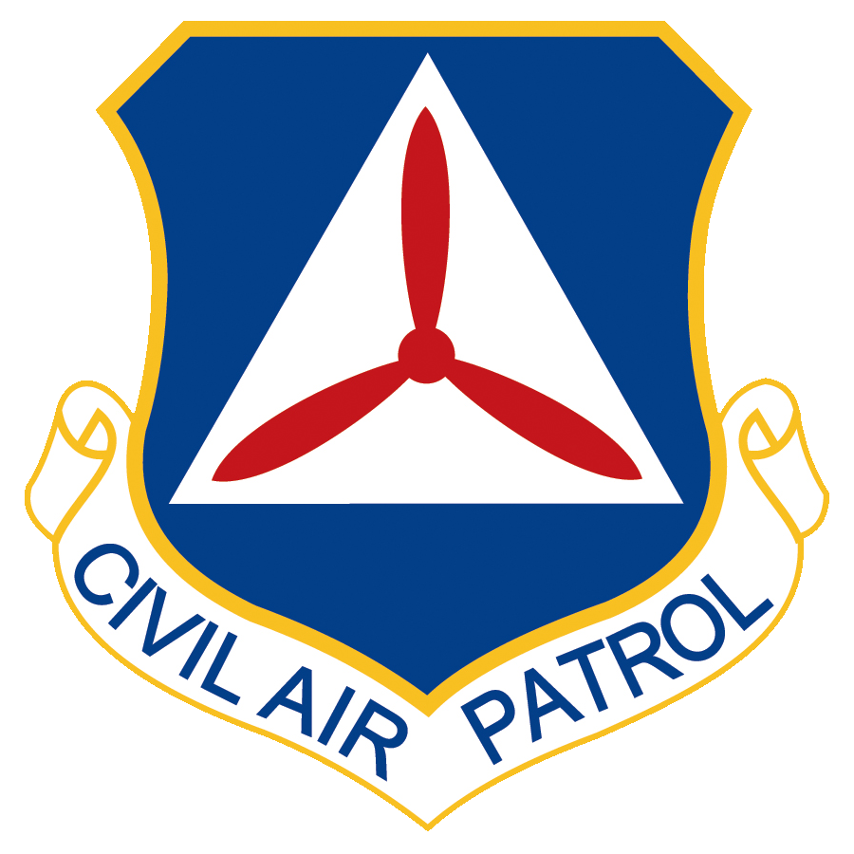
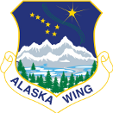

ALASKA WING HEADQUARTERS
CIVIL AIR PATROL
UNITED STATES AIR FORCE AUXILIARY
BLDG 16322 37th St
Elmendorf AFB AK 99506-391

6 June 2022

MEMORANDUM FOR AKWG CADET ADVISORY COUNCIL REPRESENTATIVES

FROM: C/Lt Col Annika E. Ziesmer

SUBJECT: CAC Meeting Minutes for 6 June 2022

1. Listed below are the minutes of the AKWG Cadet Advisory Council meeting of 6 June 2022, which was held on Google Meet Code cgk-uwbe-tpn at 1830 AKST hours.

2. OPENING BUSINESS:
a. Role Call
C/Lt Col A. Ziesmer, Chair, Lake Hood - present
C/Lt Col A. Padgett, Vice Chair, Lake Hood - absent
C/Lt Col K. Lukic, Recorder, Polaris - present
C/Capt Michael Porter, RCAC Representative, Polaris - absent
C/Capt T. Weisensel, Fairbanks (P) - absent
C/CMSgt A. Smoot, Fairbanks (A) - absent
C/SrA L. Cole, Kenai (P) - absent
C/SrA L. Schwartz, Kenai (A) - present
C/1st Lt R. “Viking” Anderson, Polaris (P) - absent
C/Capt M. Anderson, Polaris (A) - absent
C/MSgt O. Bender, Arcturus (P) - absent
C/SrA A. Pietan, Juneau (P) - absent
C/A1C A. Coppin, Juneau (A) - present
C/CMSgt J. Fox, Delta (A) - absent
C/Amn A. Mangini, Eielson (P) - present
C/Amn C. Brass, Eielson (A) - absent
C/SMSgt Ch. Wise, Valdez (P) - absent
C/SMSgt Ca. Wise, Valdez (A) - absent
C/SSgt T. Moehring, Birchwood (P) - present
C/SrA T. Haley, Birchwood (A) - absent
C/SSgt S. Briar, Tok (P) - absent
C/2d Lt H. Simeonoff, Kodiak (P) - present
C/TSgt Liam Long (A) - absent
C/SrA R. McCoy, Gateway (P) - absent
C/TSgt N. Robbins, Gateway (A) - absent
C/1st Lt S. “Bam-Bam” Mellerstig, Lake Hood (P) - present
Maj J. Bittle, AKWG/CP, Senior Advisor - present
Col K. McClure, AKWG, Wing Commander - Present
Capt K. Padgett, AKWG/CP, Director of Cadet Programs - Present
b. The minutes were read and accepted unanimously by voice vote
c. Squadron and Senior Advisor’s Report
1. Region - Region’s current projects include STEM expansion, public relations, patch/emblem standards, and the GREAT START revamp.
2. AK-011, Kenai - has been working on completing cadet powered o-rides.
3. AK-015, Polaris - has joined together with Lake Hood for the summer with C/Captain Porter as the new cadet commander. Polaris is now working on fundraising opportunities for the summer.
4. AK-017, Arcturus - has been working on preparing for ES SAREXs, primarily on water purification.
5. AK-022, Southeast - three new prospective cadets have joined, participated in multiple color guard events and have been preparing for future color guard events.
6. AK-071, Eielson - Preparing for encampment drill, and recently visited aircraft refuelers, and has been working on cleaning the squadron building.
7. AK-076, Birchwood - working on encampment preparation, and working on
opening staff applications.
8. AK-087, Kodiak - Recently had visiting cadets come down for color guard training, and has been working on fundraising as well.
9. AK-, Tok - Four cadets will be attending encampment, and C/2d Lt Briar is
staffing the national cadet competition.
10. AK-093, Lake Hood - Continuing joint ops with Polaris and have many fun activities planned for the summer.
11. Major Biddle (Senior Advisor): Looking forward to working with cadets at
encampment.
12. Capt Padgett (Director of Cadet Programs), Wing activities - Looking forward to working and meeting new cadets at encampment. Two cadets went down to Kodiak to receive color guard training with the national judges. June 21st at 0800 black hawk o-rides will be available in the Anchorage bowl area at the Boniface Gate. Alaska SAREX opportunities are occurring towards the end of the summer. Encourages CAC representatives to relay TRUST certificate information. Wing Conference will be in-person the first week of October with lots of cadet activities available. First week of December will be a hybrid AKWG color guard competition. The goal is to have 10+ teams participating. More cadet opportunities and information to follow.
12. Col McClure (Wing Commander): Went down to Kodiak to meet the team. Wing commanders had a conference with Region commanders and will have safety information regarding airplanes.

3. OLD BUSINESS
a. Improve Communication in Alaska Wing (Chair-C/SrA Schwartz, C/Capt Porter): Further discussing different options for improving communications across the wing. Current list of possibilities include encouraging more use of AKWG eMail accounts and google spaces and looking into new options such as discord, and GroupMe. C/Lt Col Ziesmer would like to work on testing different options of communication.
b. Making CAP life easier for new cadets to figure out (Chair-C/MSgt Bender, C/Lt Col Lukic, C/2d Lt Simeonoff): C/MSgt Bender will provide an update on the areas identified at the previous months meeting as ways to help new cadets which include drill and eServices tutorials and ideas to help new cadets learn the cadet oath. C/Lt Col Ziesmer recommended C/MSgt Bender get in contact with C/CMSgt Fox to work together to mutually benefit each committee.
c. Mistakes in the Journey of Flight textbook (Chair-C/Capt Weisensel, C/Capt Anderson, C/CMSgt Fox): The council will continue the discussion surrounding the proposal. Updated advocacy paper was distributed. AKWG CAC is encouraged to submit feedback.
d. eServices Redesign: C/SrA Pietan will provide a progress update on the eServices redesign proposal. C/SrA Coppin has informed the CAC that they are focusing on reorganizing the homepage to make it more accessible.
e. Involve Cadets In More Operations (Chair-C/2d Lt Weisensel, C/Lt Col Lukic, C/SSgt McCoy, C/CMSgt Fox): C/Capt Weisensel will provide an update to the council on the progress being made by this committee
1. GES Subcommittee: Lt Baugh has agreed to be the SM POC. Currently working on finding an interior cadet POC to work with the Anchorage bowl cadets to achieve an organized SAREX for all of Alaska this August.
2. sUAS Subcommittee: C/SSgt McCoy will provide update with a discussion emphasis on obtaining TRUST certificates (https://trust.modelaircraft.org/group/4?tour=1) as well as any feedback for the PowerPoint regarding this topic that was distributed after last meeting
f. Video Committee (Chair-C/CMSgt Fox, C/1st Lt Mellerstig, C/SrA Haley): C/CMSgt Fox will provide updates on the topic. C/1st Lt Mellerstig relayed that the committee is currently working on contacting the necessary members.

4. NEW BUSINESS
- Open Floor
- C/MSgt Bender proposed that Powerpoint presentations regarding certifications for cadets would be beneficial as it worked well for the TRUST certificate. Captain Padgett offered to put any previous powerpoint presentations on the AKWG website for cadets to access in an efficient manner.

5. ADJOURN: The council was adjourned at 1924 hours. The next meeting is 11 July 2022 at 18:30 AKST on google meet code cgk-uwbe-tpn.

//Signed, kel, 6 June 22//
Katarina E. Lukic, C/Lt Col, CAP
AKWG Cadet Advisory Council Recorder

