FY 2022 SMART Cadet Programs Goals

PCR-AK-0XX <Name> Squadron
1 Sep 2021-31 Aug 2022 <SquadronName> Squadron Annual Goals (cao 16Oct21)
(Dates to match with QCUA dates)

NHQ Communicates Cadet Programs strategic goals each year by adjusting Quality Cadet Unit Award (QCUA) criteria. A unit can align their goals best with CAP’s most important goals for cadet programs by striving to achieve at least 6 of the year’s 10 below criteria, thereby achieving the QCUA.

Year-start summary: Minimum goal achieve QCUA (6 of the 10 goals). [Feel free to add additional stretch goals] See attached QCUA details

To Update: Run a QCUA Report. Log in ~31 Dec 2021, ~31Mar 2022, ~30 June 2022 & 31 Aug 2022 to update & save this file with a new date in the name.

Year-end summary: (Fill in ~31 Aug 2022)

NOTE: All unit goals are reviewed once per quarter
To qualify for QCUA award, meet at least 6 of the 10 criteria below
- Membership Goal—Maintain at least 20 cadets (NOTE: There is no growth goal per se for FY 2022. 20 cadets is just *one* of the 10 criteria. Need only 10 cadets to be eligible)
  - 31 Aug 2021 # Cadets:
  - 31 Dec 2021 # Cadets:
  - 31 Mar 2022 # Cadets:
  - 30 Jun 2022 # Cadets:
  - 31 Aug 2022 # Cadets:

- Onboarding: Cadets joining after 31 Aug 2021 who earn Curry within 8 wks or by 31 Aug 22, whichever is earlier. (Monitor closely near end of fiscal year) Goal: 80%
31 Aug 2021: 0/0=0%
31 Dec 2021:
31 Mar 2022:
30 June 2022:
31 Aug 2022:

- Cadets with Wright Brothers Goal (monitor closely as you add cadets): 40%
31 Aug 2021:
31 Dec 2021:
31 Mar 2022:
- Jun 2022:
- Aug 2022:

- Cadets with at least 1 O-Flight Goal: 70%
31 Aug 2021:
31 Dec 2021:
31 Mar 2022:
- Jun 2022:
31 Aug 2022:

- Cadet with Encampment Goal: 55%
31 Aug 2021:
31 Dec 2021:
31 Mar 2022:
30 Jun 2022:
- ug 2022:

- Cadets with GES Goal: 60%
31 Aug 2021:
31 Dec 2021:
31 Mar 2022:
30 June 2022:
- ug 2022:

- Outside Activity: RRLA, CyberPatriot, Team America Rocketry Challenge, StellarXplorers, UAS4STEM, (others may be added—Adopt a Classroom?)
31 Aug 2021: none yet
31 Dec 2021:
31 Mar 2022:
30 June 2022:
- ug 2022:

- Aerospace Goal: AEX or STEM Kit Goal: 1 (NOTE: Also see unit AE plan these criteria may be a part of)
31 Aug 2021: none yet
31 Dec 2021:
31 Mar 2022:
- June 2022:
- Aug 2022:

- Seniors with TLC Goal: 3 (2 are required just to have unit in compliance!)
31Aug 2021:
31Dec 2021:
31Mar 2022:
30 June 2022:
31 Aug 2022:

- Senior Members with Cadet Programs Specialty Track Rating Goal: 2 (National prefers units have at least
31Aug 2021:
31Dec 2021:
31Mar 2022:
30 June 2022:
31 Aug 2022:

QCUA Criteria Met: Goal 6 of the above 10 numbered criteria
31 Aug 2021:
31 Dec 2021:
31 Mar 2022:
30 June 2022:
31 Aug 2022:

Attachment 1: How to Find Your Unit’s QCUA Data:
To update your goal numbers:
Log into eServicesReportsMember Reports
Member Reports (red pulldown menu)Member ReportsQuality Cadet Unit Report (shows unit numbers to update unit goals)

To see which specific cadets meet each criterion:
Log into eServicesCadet ProgramsCadet Promotions
Cadet Promotions (red pulldown menu)QCUA Details

Attachment 2: QCUA info for 31 Aug 2021 to 31 Aug 2022 from https://www.gocivilairpatrol.com/programs/cadets/cpofficer/quality-cadet-unit-award
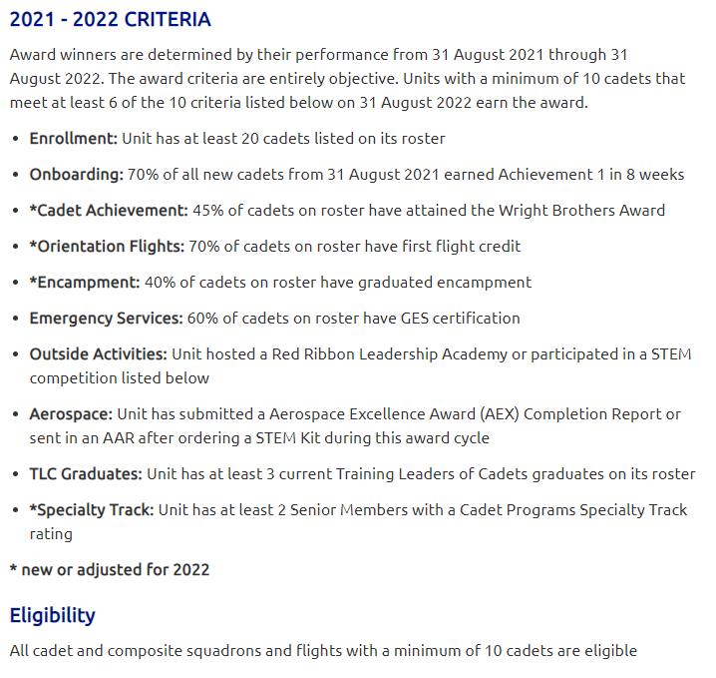

Attachment 3: How to meet Emergency Services Goal (GES-116)
- Have each cadet log into AXIS
- (Senior Members can take the test too)
- In course catalog, search for “CAPT 116 General ES”
- Have CAPR 60-3 open in one tab to take the test open-book
- Passing score for the test is 72%. There is no time limit. Test can be taken again immediately if not passed.

- Possible to also administer in a group setting & enter group data. Contact karen.padgett@akwg.cap.gov for more info

Attachment 4: More info on “Outside Activities”
More info available here: https://www.gocivilairpatrol.com/programs/cadets/cpofficer/quality-cadet-unit-award

Attachment 5: How to earn AEX Award
- As soon after 1 Oct as possible, Squadron Commander or AE Officer must
- Log into eServicesAerospace EducationAEXApply for AEXChoose 2021-2022 school year, “unit” radio button, and an activity bookSubmit
- THEN keep track of the dates & # cadets involved in six 15-min+ hands-on Aerospace activities the cadets complete and a 2-hr field trip or other AE activity (can be virtual). Can all be done in a one-day activity if necessary
- Sq CC or AE Officer then logs into eServicesAerospace EducationAEXAEX Award ReportEnter datasubmit

Attachment 6: How to get STEM Kit credit
- As soon after 1 Oct as possible, Squadron Commander or AE Officer must
- Log into eServicesAerospace EducationCAP STEM Kit
- THEN keep track of the dates & # cadets involved in six 15-min+ hands-on Aerospace activities the cadets complete and a 2-hr field trip or other AE activity (can be virtual). Can all be done in a one-day activity if necessary
- Sq CC or AE Officer then logs into eServicesAerospace EducationAEXAEX Award ReportEnter datasubmit

Attachment 7: How to find out about upcoming TLC classes
Check here: https://akwg.cap.gov/programs/cp/tlc
Check Facebook Page: “Civil Air Patrol – Virtual Trainings”
Contact karen.padgett@akwg.cap.gov

Attachment 8: How SMs advance in the Cadet Programs Specialty Track
See CAPP 60-11
See checklists in spreadsheet form here: https://akwg.cap.gov/programs/cp/cpos
Contact karen.padgett@akwg.cap.gov to find a mentor

